# READ ME:

([**Tug03425@temple.edu**](mailto:Tug03425@temple.edu), 610-316-1354, SKYPE)

Watch Mes didn’t record correctly I think, but I don’t have a good movie watcher on my pc.

I don’t have a lot of time between the end of the program and August 10th (DATE OF DAT). Afterwards I can provide additional help for understanding what I did. 

# Basic Files for Jake’s Summer Research Work:

1. function_farm.ipynb

2. function_farm.py

3. iPAU1129 --- (xml file)

4. PA14_Changes_Mass_Balance-Copy1.ipynb

# Overall Goals:

Alter media conditions and/or carbon sources.

Make mass imbalanced reactions better.

# Folders in File

1. Jakielaszek_Summer_2018

a. ProbablyIrrevelant - You can peruse these if you find that something doesn’t inherently work.

b. Relevant – Mass/charge imbalances & missing genes

A_Important_Folder – Major functions and what I was ultimately trying to do.

MassImbalancedReaction – How I got the list of bad reactions (some parts may be missing because I overwrote things as I went along and hopefully didn’t delete anything important)

# Weird Nuances:

1. You **must** run function_farm.**ipynb** before making changes in the PA14_Changes_Mass_Balance-Copy1. You can just delete function_farm.**py** recursive call to recreate itself as a python file to remove the red printout when you run PA14_Changes_Mass_Balance-Copy1.

2. You probably don’t have some modules installed like openpyxl, but if you don’t it will provide you with instructions on what to do.

3. Sometimes the jupyter notebook compiler crashes. I wasn’t able to figure out why. It will either say something like ‘jupyter notebook compiler stopped’ or it will forget a variable/function like the copy module. I suspect this may have to do with my usage of the **del** function.

4. Addressing 3. I was importing files to get function_farm to work, but not importing them redundantly to in the PA14 changes file. It appears to work, but the double import seems redundant. I suspect it has to do with the variable and namespace aspect of assigning variables to memory addresses. Also, it died because it ran out of memory on my PC. My dream of doing all of this in one huge file seems to be unfeasible.

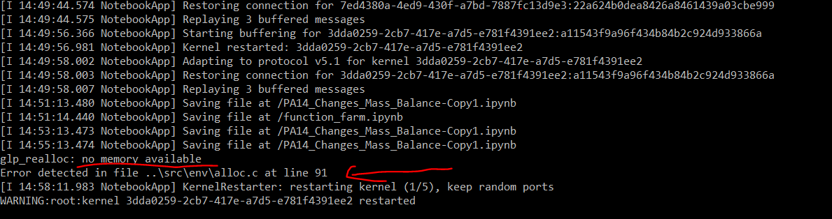

# Pseudo code for function_farm.ipynb:

Import files necessary for function_farm function

**checkFreeMass** – checks for free mass

**changeMedia_PA_LJD** – change the media of **ONE** carbon source in one of three medias

**minimal_media_conditions** – change to M9 minimal with **multiple** carbon sources

**minimal_media_varied_carbon** – utilizes above functions to output excel file with objective values on various carbon sources

**results_genes_flux** – flux through a reaction(s) and single gene deletions

**compared** – compares old flux values generated from minimal_varied_carbon with new flux values after a reaction change

# Pseudo code for PA14_Changes_Mass_Balance-Copy1.ipynb:

1. Load the model

2. Get flux results, single gene deletion results and objective values for the reactions and genes in the unaltered model.

3. Change a reaction

4. Get flux results, single gene deletion results and objective values for the altered model

5. Compare base model with the temporary model

6. Add changes if desired to overall model

Repeat 3-6.

# Future Development:

Single gene deletion results to an excel file. Compare relevant genes.

Equate the ‘(+-) and (-+) carbon sources’ with the changed growth results to alert user to changes that are relevant similar to the meaningful_changes variable created.

Clean up the code more. Its giving me an aneurysm.

Fix the memory allocation issue. I didn’t see my RAM actually fill up to use 8 GB, so I assume it has to do with kernel having a specified allocated amount that can’t be exceeded so it stops.